Beach school: 'Here they are free to explore and to learn’
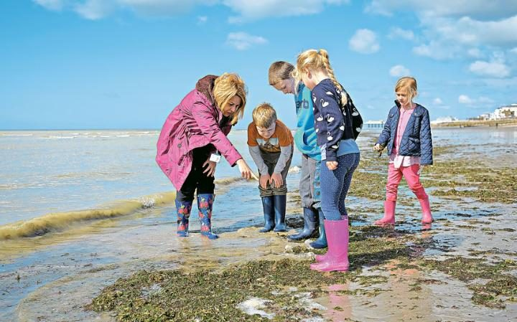
Tide turns: Lyndhurst First school pupils with Di Bearham on Worthing Beach, Sussex Credit: Christopher Pledger

16 April 2016 • 9:12am
'This,” says six-year-old Summer breezily, “is the jacuzzi.” She shows off the water slide, main living area, entrance and soft furnishings – namely seaweed.

Summer, and the children listening intently as she trots through her estate agent spiel, are enjoying a morning at beach school.

The pupils at Lyndhurst First school in Worthing have decamped to the seaside – a 10-minute walk from their classrooms – for some unusual lessons.

Their task is to use the natural resources of the beach to create a home fit for a sea creature. The seaweed, says Summer’s partner, Lacey, will allow a crab – their target tenant – to escape the attention of seagulls.

Outdoor learning has been growing steadily in the UK since the Nineties, when the first forest schools began to emerge.
Inspired by the Scandinavian model, as well as home-grown traditions such as scouting, regular access to a woodland environment is said to boost not only academic performance, but also children’s confidence, self-esteem, social skills and wellbeing.

Growing numbers of schools now offer outdoor curriculum time. In many urban areas, parents concerned their children are denied the free-range childhood they themselves enjoyed, pore over school websites in search of fresh air and a modicum of risk.

With the UK fringed by more than 11,000 miles of coastline, using the beach in a similar way seems a logical progression.
Forest Schools Education created the first accredited beach school training programme for teachers five years ago. It now runs eight courses a year. “They are well subscribed, though more popular in summer than winter,” says executive director Paul Moseley.
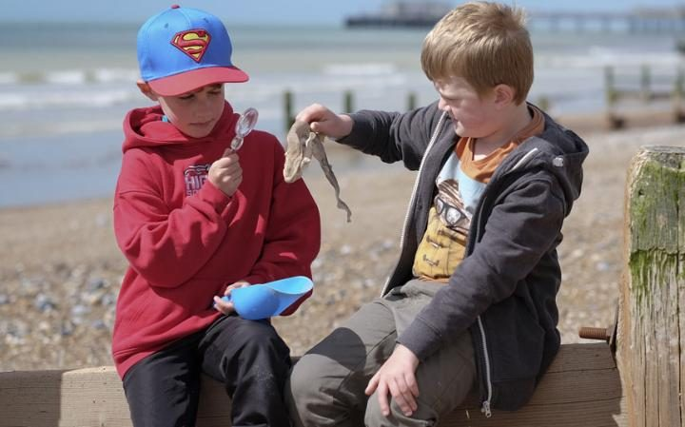
During a beach lesson on Worthing Beach Credit: Christopher Pledger

Di Bearham, a higher level teaching assistant at Lyndhurst, is in charge of today’s outing. She has been running its beach school programme since completing training two years ago.

Each class visits the beach twice a year – winter and summer – and smaller groups are taken on additional three-week courses. Only twice has rain stopped play.

“Unless it is absolutely filthy, we are down here,” Bearham says. Extra layers, a bothy bag shelter and an occasional flask of hot chocolate are sufficient to address most conditions.

“It is about exploring for themselves, finding things that are real,” she says. “As well as fresh air and exercise, they think about their environment. They can hear, smell and touch things, go into the water. They have the freedom to learn.”

The effect on children’s self-esteem and confidence can be profound. says Bearham. “We often see a different child at the beach. One boy told me he loved coming because he was rubbish in the classroom but he was good here. Others have spoken in front of their classmates for the first time after a beach trip. Children who have trouble controlling themselves often readily take turns and listen to others here. There are no wrong answers. It is about their interpretation, so children succeed.”

The tide is coming in, so the children leave the rock pools and move higher up the beach. They will use the photographs they have taken to create identification charts for younger children.

James, eight, empties his wellies. He has found some interesting seaweed. Skylar, six, has spotted a saddle oyster and some crab legs. “I love coming to the beach,” she says. “I like the sound of the sea and all the pretty shells.”

Snack time is called, but then postponed as one of the adults waves a dead fish in the air. “It’s a shark,” comes the cry from the tangle of heads that quickly surrounds her. Though a long way from Jaws dimensions, the well-preserved creature sports rows of razor-sharp teeth. “It is a cat shark,” announces a child knowledgeably.
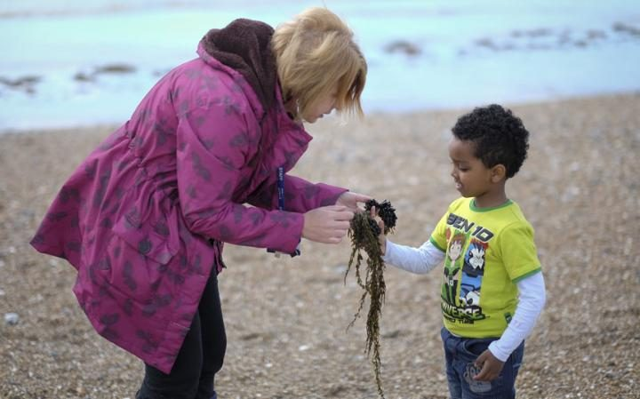
Sea, sand and seaweed: beach school has a 'calming' effect Credit: Christopher Pledger

Di tells the children the species is also known as dogfish. They prefer the shark-based version and conclude it was caught in the nets of one of the fishing boats that line the beach.
With the sea encroaching noisily up the pebbles, the children settle for a snack and discussion about their findings (as well as the best way to eat a custard cream). “I would like people to keep our beach cleaner, to put their rubbish in the bin and clean up dog poo,” says James, before asking: “Can we do some more work now?”
The session ends, as always, with a game – this time a chasing game called “sharks, crabs and jellyfish” – and some free time. Lacey, burying Summer’s legs, is “turning her into a mermaid”. Max and Jack have rigged up a makeshift game of bowls with some large stones. Skylar and James, meanwhile, are perched atop a wooden groyne, staring quietly out to sea.
“It has a calming effect,” says Bearham. “There are never behavioural problems down at the beach.”
With perfect timing, clouds begin to gather and the children set off. “When can we come again?” asks Jack.
Back at school the beach explorers are absorbed into the day’s routine. The results of their outings adorn the walls – poems on the theme of “winter beach”, talk of “the taste of the salty sea air” and “a snapped cuttlefish bone as white as snow and paper”.
Making their experiences real and using their senses improves their science, speech, writing and art, says deputy head teacher Jo Halley. “It brings their learning alive.”
Summer is clear about the value of her seaside lessons. “After being on the beach,” she says, “I feel very happy.”
Details of beach school programmes: forestschools.com. Information on outdoor learning is also available at wildlifetrusts.org

