Parent Workshops
We hold workshops in school aimed at informing parents on the way that we teach calculations.
Calculation Workshops.
All Lyndhurst parents are given copies of our Progression In Calculation documents that show the stages of development when teaching addition and subtraction, multiplication and division. (If you don’t have a copy then they are available to view on our website under the Numeracy section. Alternatively please ask at the school office for a paper copy).
During the workshops we talked through the methods that are taught at Lyndhurst and explore some of the resources that children use in school.
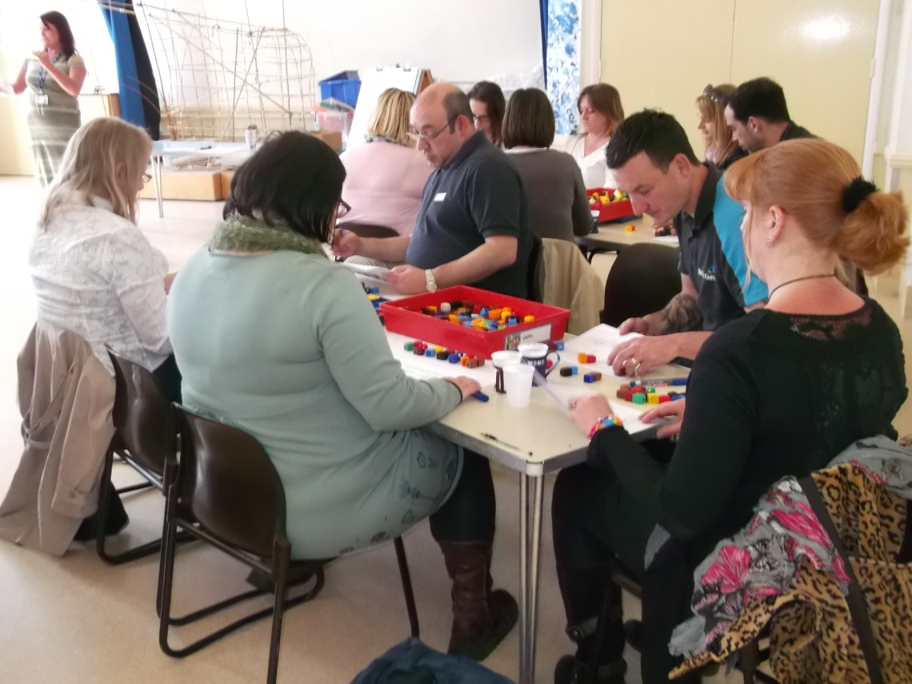
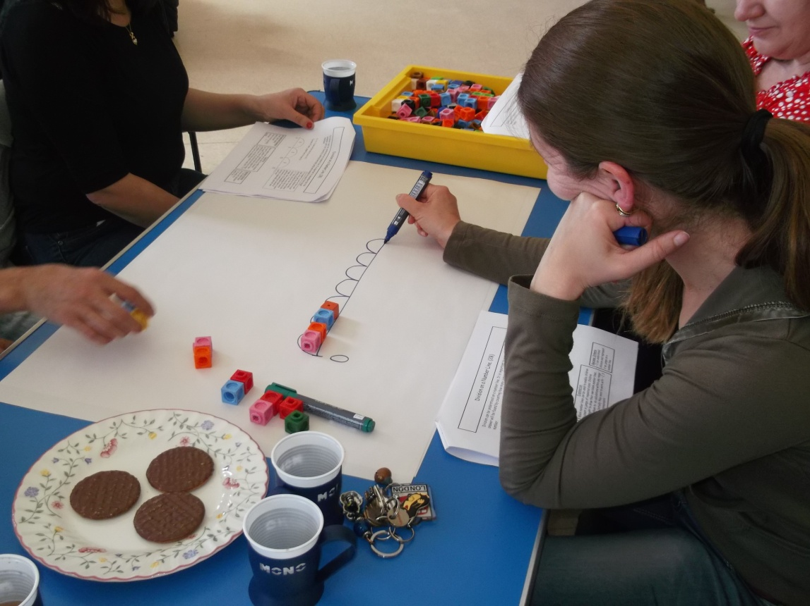
Following this, parents went into class to join in a Maths lesson alongside their children.

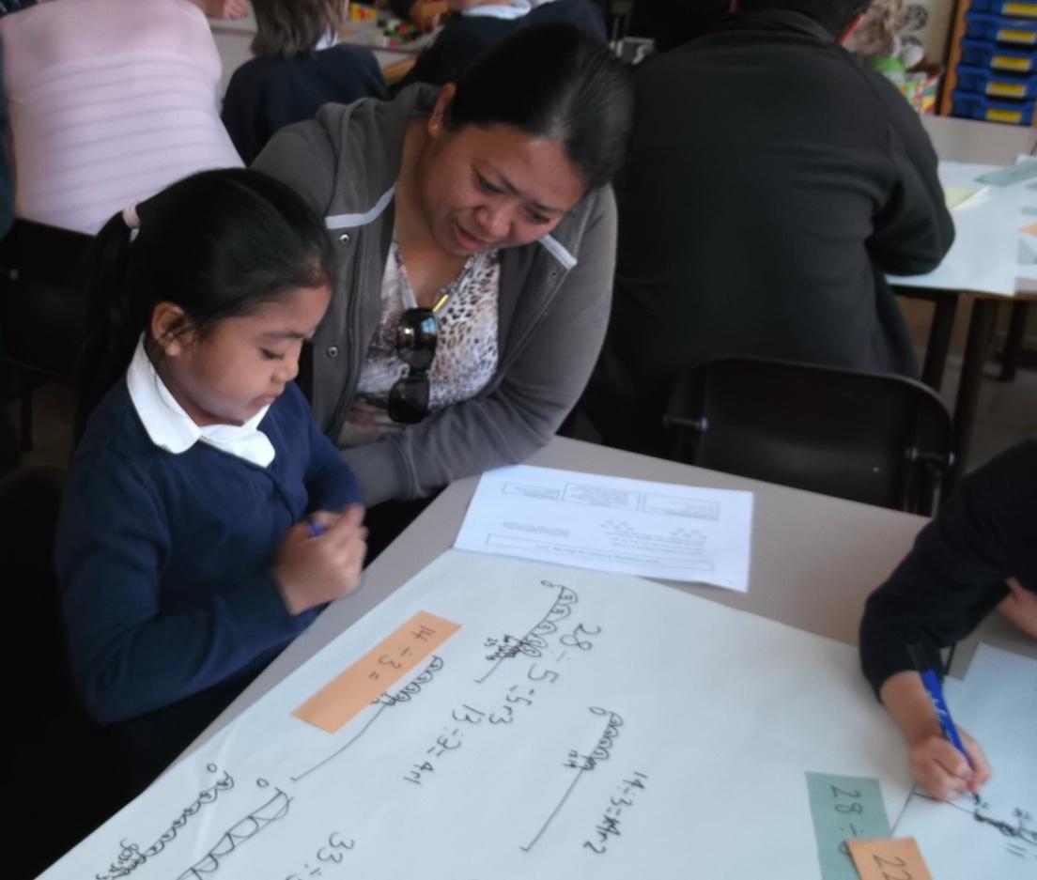

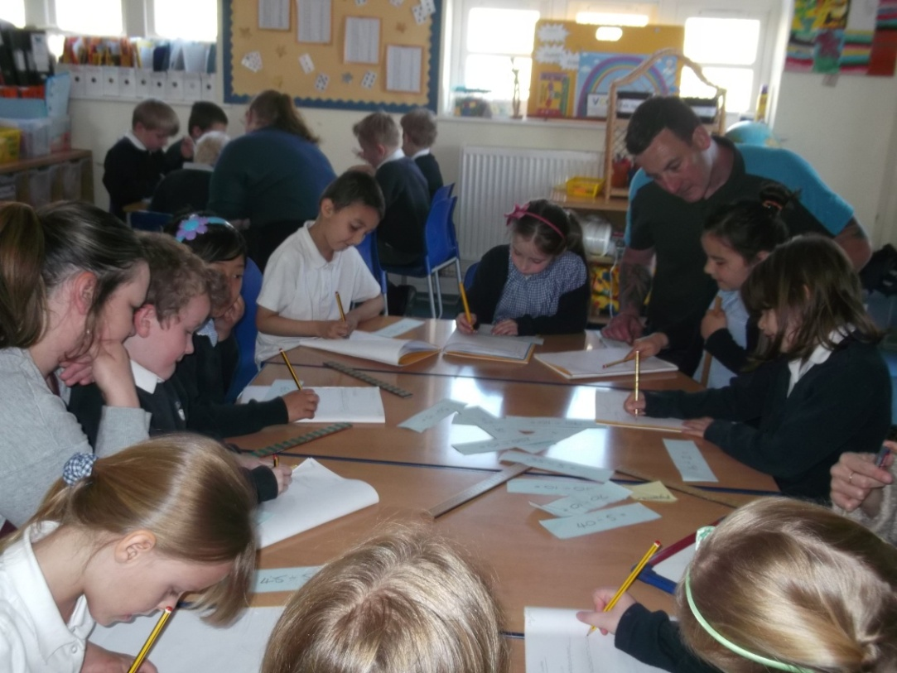
We like to make the most of our school environment and some lessons took place outside in the playground!
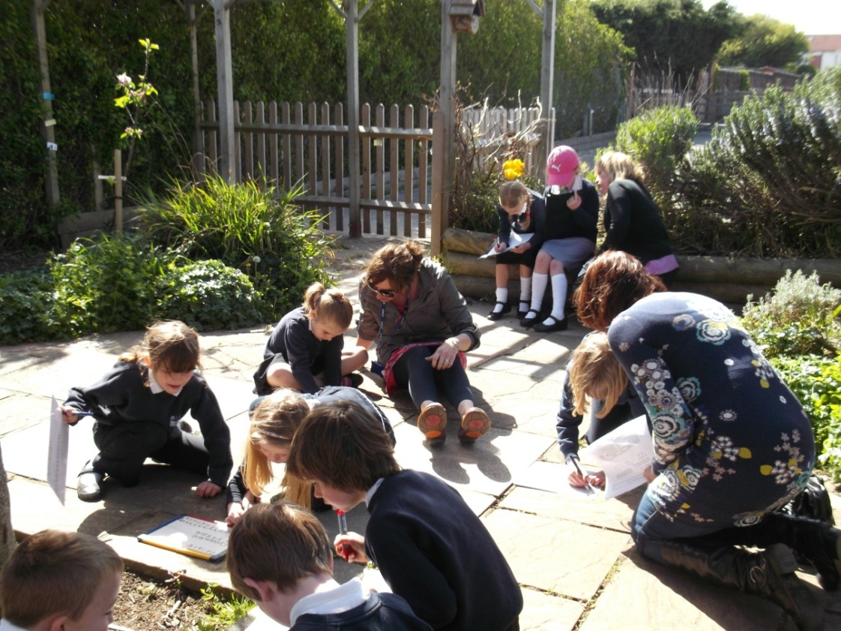

Mental Calculations.
During Maths week in October 2014 we ran a workshop on mental calculation expectations. The new curriculum for Maths has high expectations for the mental skills children should be able to do by the end of each year group. Parents and carers had the opportunity to learn how to play some games that support these mental calculation expectations in a fun way. To see the list of games look at the ‘Games To Play At Home’ link in the Maths section of our website. Any queries, questions or if you just fancy having a go at the games before you buy them then come and see Mrs Halley.

